**February 19**

Creating repo, creating team, first discussions [ALL (online)]

**February 24**

Dataset chosen: [Temperature change](https://github.com/stacyshki/TemperatureChangeVisualization/blob/main/Environment_Temperature_change_E_All_Data_NOFLAG.csv) [ALL (online)]

README created [Viktor Korotkov]

**February 25**

Project discussion and plan visualization [ALL (offline)]

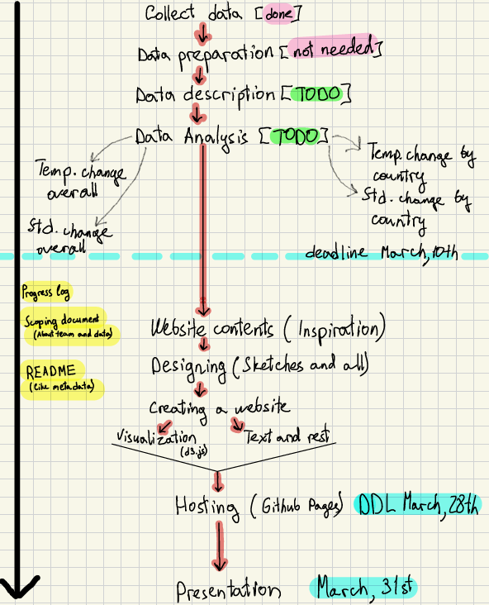

**March 5**

Global temperature change analysis [Shitao Zhao]